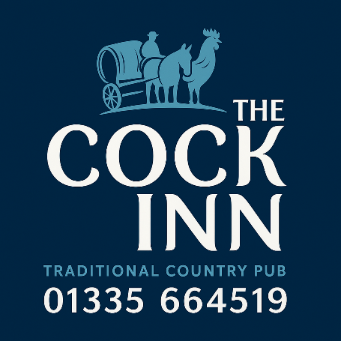

Small plates
French Onion Soup £8 GFO V
with cheese crustini
Crispy Chicken Wings £8
BBQ, sauce.
Homemade pork & chicken liver pate £8
Served with house chutney and mixed leaves & crusty bread
Smoked Salmon £9 GFO
served with salad, brown bread & butter
Lamb Koftes £8
with mixed leaves & yogurt & mint sauce
King Prawns Pil Pil £9 GFO
pan fried in garlic & chilli butter, crusty bread
Salt n pepper Squid £9
mixed leaves, garlic mayonnaise
Pub Classics
Beer-Battered Hake & Chips £18
Fresh fish in a light ale batter, served with chips, mushy peas, and tartare sauce.
Pie of the Day £18
Handmade pie served with garden peas and mashed potato or chunky chips
Homemade Meat Lasagne £14 Vegan Lasagne £14 VG GFO
Served with salad & chunky chips
Classic Scampi & Chips £15 GFO
Breaded wholetail scampi, chunky chips, garden peas, and tartare sauce.
Mediterranean Vegetable Tart £14 VG GFO
with chunky chips & salad
Honey glazed Ham £14 GF
served with 2 fried eggs, chunky chips & peas or baked beans
Cajun Chicken £17 GF
butterfly chicken fillet marinated in cajun spices with house fries, peas & coleslaw
Tagliatelle Carbonara £14
pasta in a rich cream, garlic & white wine sauce finished with smoked bacon, mushrooms and oregano

From the Grill
8oz Rump Steak £25 GF
Served with chips, grilled tomato, mushroom, garden peas.
12oz Ribeye Steak £29 GF
A richly marbled cut served with chunky chips, grilled tomato, mushrooms & garden peas
Grilled Chicken Breast £17 GF
Served with garlic butter, chips, salad

Burgers
All burgers are served in a toasted brioche bun with fries and coleslaw.
The Cock Burger £18 GFO
6oz beef patty, mature cheddar, smoked bacon, lettuce, tomato, and burger sauce.
The Hen Burger £17
Crispy chicken fillet, lettuce, tomato, and burger sauce
Minted Lamb Burger £18
6oz lamb patty, feta cheese. lettuce and tomato and yogurt mint sauce.
Moving Mountains Burger £17 VG
Plant based burger, vegan cheese, lettuce, tomato, and vegan mayo.

Salads, Sharers & Flat Breads
Chicken Caesar Salad £14
Crisp romaine lettuce, parmesan, croutons, and Caesar dressing, crusty bread & butter.
Greek Salad (V) £14
Feta, tomatoes, cucumber, olives, peppers and balsamic dressing, crusty bread & butter.
Cold Meat Platter £14
ham & beef with garden salad, crusty bread & butter.
Flat Breads with Fries & Coleslaw £14
Cajun Chicken or Lamb Kofte or Halloumi.
Countryman's Lunch £24
Cheddar, Stilton, Double Gloucester Cheese, Ham, Beef, Pate & pork pie, pickles, salad, and crusty bread.

Seafood Platter £26
Smoked salmon, Smoked Mackerel, Prawns Marie Rose, Salt n Pepper Squid & Scampi with Salad, Tartare Sauce, Garlic Dip, Crusty Bread & Butter

Children's Menu £10
Fish Fingers
Chicken Nuggets
Sausage & Mash
Lasagne with Garlic Bread
Cheeseburger
All child meals come with fries and the choice of beans and peas.
All children's meals include an iced lolly or scoop of ice cram

Sunday Roast £18
Available every Sunday from 12 noon.
- Roast Beef
- Roast Chicken
- Roast Lamb
- Vegetarian Roast
All served with roast potatoes, mashed potatoes, Yorkshire pudding, seasonal vegetables, cauliflower cheese, and pan gravy. GFO

Breakfast served every Saturday 9.00am to noon

Side Orders
Chunky Chips 4.00 with cheese 5.50
Skinny Fries 4.00 with cheese 5.50
Garlic Bread 4.00 with cheese 5.50
House Salad 4.00
Buttered Seasonal Vegetables 4.00
Beer Battered Onion Rings 4.00

